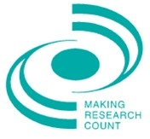
Developing an approach to engaging fathers within children’s social care
What is Making Research Count?  Making Research Count (York) is the regional hub for Yorkshire and the Humber. We work in partnership with a number of local authorities’ Children’s and Adults’ Services teams across the region to support the continuous professional development needs of their staff. Places at our events are also available to delegates from other local authorities, health services and local, regional and national voluntary and community groups and charities.  The course considers  Gavin Swann of the London Borough of Croyden will lead this interactive event, enabling delegates to consider  - The personal and professional context of engaging fathers  - Findings of literature review and research study  - How to include fathers in social work interventions and services  - How to transfer learning to social work practice  Testimonials  Interesting event helps you think  more in depth, highlighted that  we are doing some good work  incorporating relevant areas  As always, very thought provoking  but with some solutions  Will definitely apply directly in  practice  good discussion group,  really well managed and really  relaxed and productive. Fabulous  day all round |  | Date: 25th Feb 2016  Time: 1.30pm to 4.30pm  Venue: Innovation Centre, York Science Park, University of York  Who is the course for  - Social workers in children and families services  - People working with children at risk and with looked after children  - Staff from voluntary groups and charities providing family support  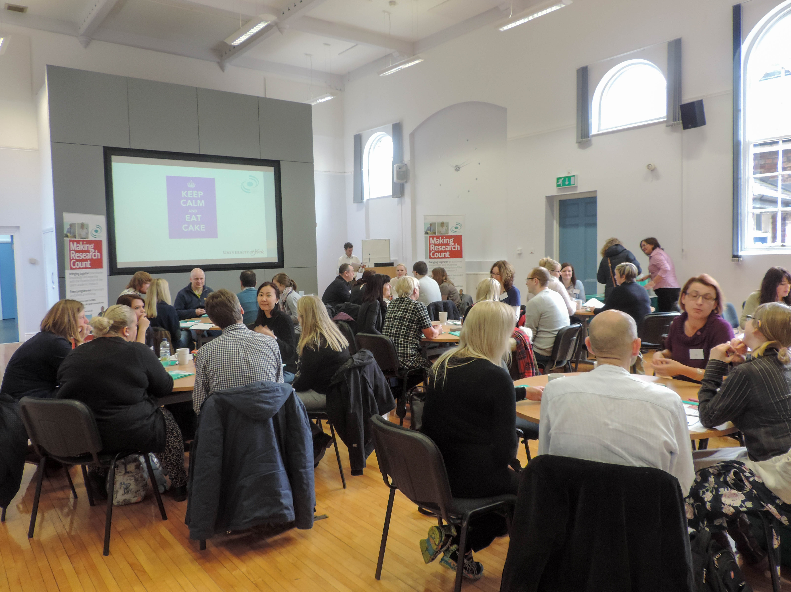  How to book  The Making Research Count seminar programme is FREE to subscribing members. Please contact your workforce development contact for details.  For others there is a fee of £75 for this event.  A bursary scheme is available for small organisations, students and those on low incomes.  Please contact our office for further details. Booking forms available online or by email/phone:  spsw-mrc@york.ac.uk  01904 321237  www.york.ac.uk/spsw/research/mrc

